**Spring Web MVC and Restful Services**

**SBMS-Part2-01**

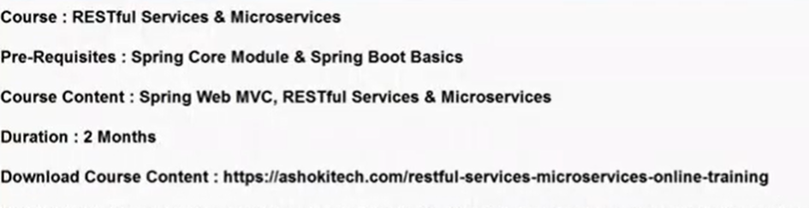

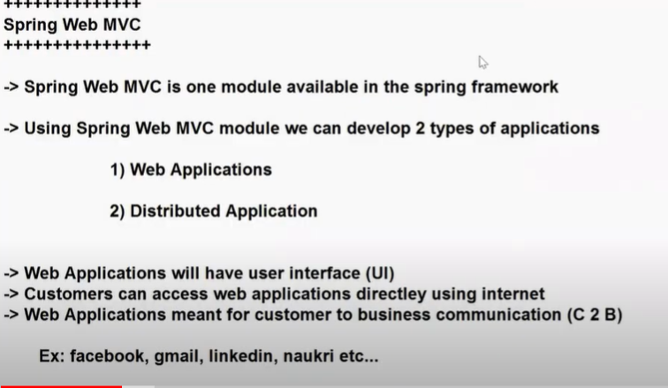

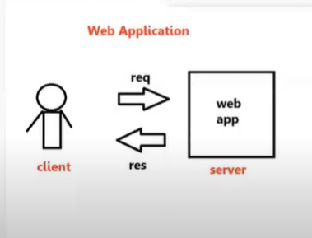

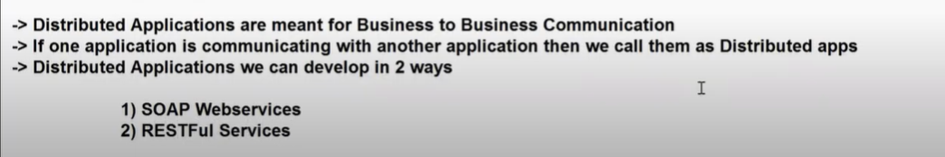





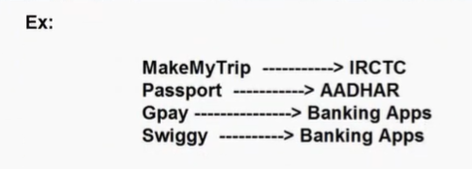

Example: MakeMyTrip application is having facility to book flight tickets, train tickets, hotel tickets etc..

We have another application called IRCTC.It is the owner of Indian Railways system.How many trains available, how many tickets available,timings of trains…all the details are available with IRCTC .

A user can book the ticket directly from IRCTC.This process is C2B communication.

At the same time, IRCTC having some business integrations also.

MakeMyTrip,Yatra,GoBibo,etcc…are available. You can book flight tickets using these apps also.

When user books a ticket by using MakeMyTrip, it will further communicate with IRCTC.

IRCTC has already a business logic implemented to book tickets.MakeMyTrip does not implement a new logic to book tickets.Instead it uses logic of IRCTC.

Whenever we want to use the logic of one application in another application, we go for Distributed applications.

If we want to reuse one project functionality in another project, we are going for Distributed applications.

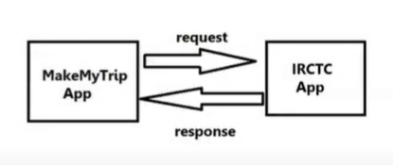

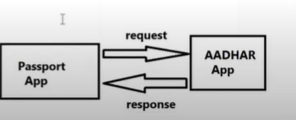

When user applies for a Passport, it asks user to enter Aadhar card number.

Aadhar app has already business logic implemented to check if it’s a valid Aadhar number.

Passport Application is doing one business and Aadhar application is doing one business.As a part of business, passport app wants to communicate with Aadhar app.This is called B2B(Business to Business) communication.

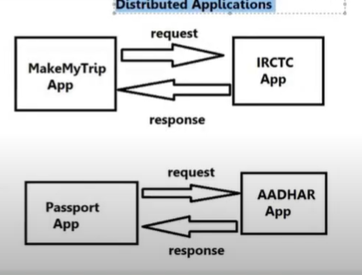

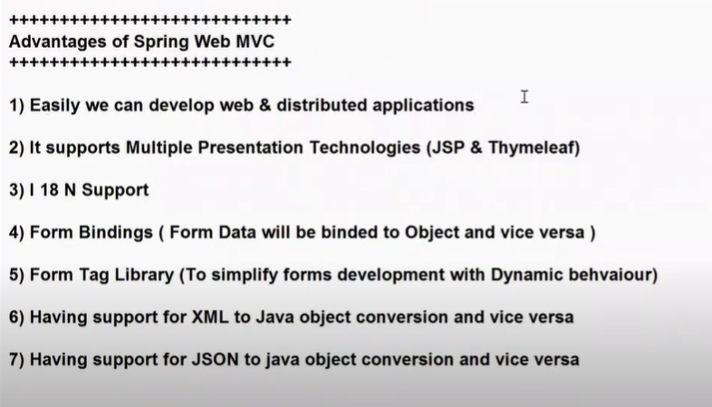

2)With Servlets, we can use only JSP to build Presentation logic.

3)I 18 N--> Internationalization--> Users across Globe can use the application. We can develop our application in multiple languages.

4)Form Bindings: For every application, Forms will be available.Whenever you submit a form, Form data will be binded to object and Object data can be binded to the form.

We don’t need to capture data by using request.getParameter() manually.

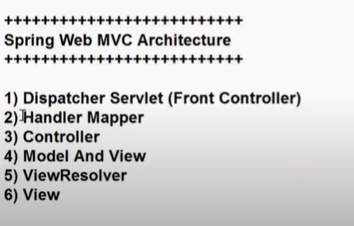

**Dispatcher Servlet: It is a predefined servlet class in web MVC. It is going to act as a Front Controller/Framework Servlet.It is responsible to perform pre-processing and post-processing of every request.**

**Pre-processing: Capturing Form data and Binding Form data to object**

**Post-processing: Sending the data to the UI and displaying data in UI**

**Handler Mapper: It is also a predefined class in Spring web MVC.It is used to identify which request should be processed by which controller class.That means it is going to identify Request Handler.**

**Controller: It is a class which will have logic to handle Request and Response.Controller is also called as Request Handler.**

**Controller is a class which contains logic to handle request and response.**

**We will create Controller classes using @Controller annotation**

**Model and View:Model represents data to display in the view and View represents logical file name.So which data should be displayed in which view page is decide by Model and View.**

**Model represents data in Key-Value pairs format.**

**View represents presentation file name.**

**To display data in view file we will use ModelandView object**

**View Resolver:It is used to identify where the view files are available in the project.**

**View: View is used to render model data on view file to display that to end user.**

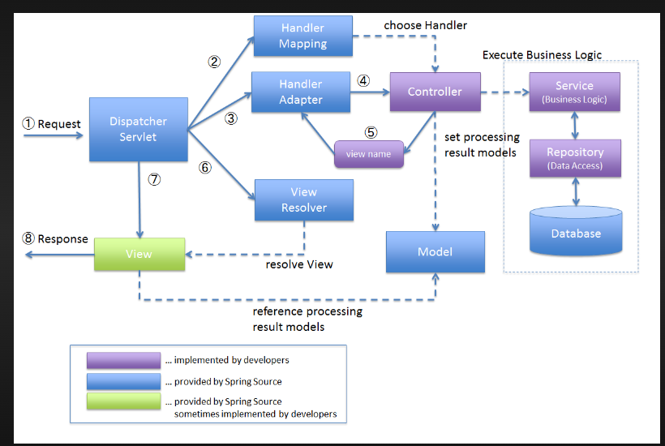

**SBMS-Part2-02**

* Dispatcher servlet will call Handler Mapper.
* Based on URL pattern, Handler Mapper will identify which request should be handled by which controller.If there is no controller with that URL pattern, then it will give 404 error
* Dispatcher servlet will call Controller.Controller will talk to service layer and then service layer will talk to DAO layer.Finally after the method execution, Controller will send data to Dispatcher servlet.
* Controller will send Data to Dispatcher servlet in the form of Model and View object.
* Spring Web MVC Supports multiple presentation technologies.It can be JSP, it can be Thymeleaf.Controller does not know which presentation technology is used in application.Controller just gives Model and View object to Dispatcher servlet.Controller does not know where the view file is present.It just gives view name.
* Dispatcher servlet will give view name to View resolver.View resolver will identify where the view file is present in our project.Physical location of View file will be identified by View resolver.
* Once it is done, Dispatcher servlet will talk to View component.Then view component is going to render that data.Then the data will be given to Dispatcher and Dispatcher will send it as a response to the user.

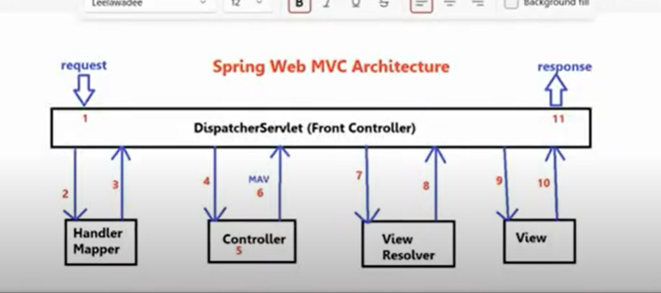

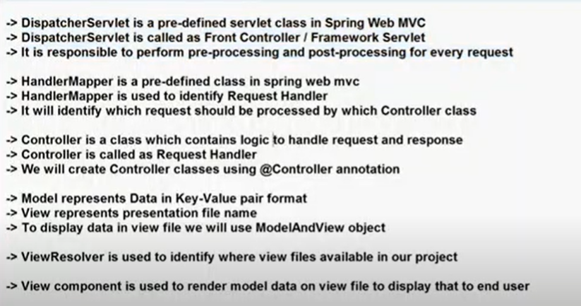

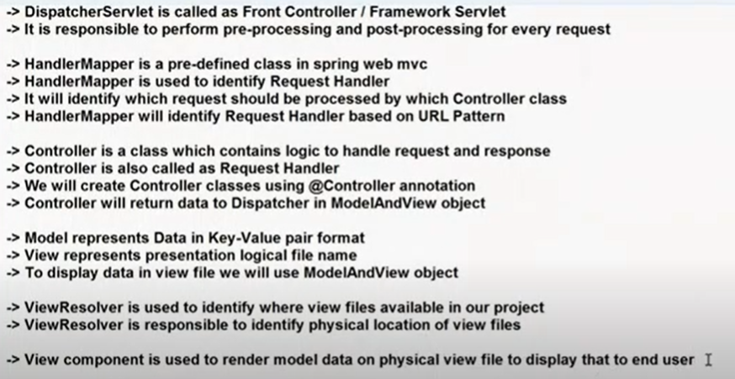



We are going to develop our first web application using Spring Boot.When we use Spring Boot, Spring boot will internally uses Web MVC to develop web applications.

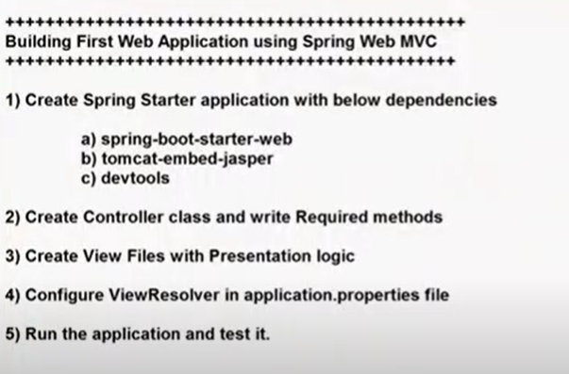

1. spring-boot-starter-web dependency:

It will provide facility to develop a web application,restful services using MVC architecture and it will provide tomcat embedded server.You don’t need to download and setup tomcat server manually.It will be taken care by web-starter.

We don’t need to setup the server, install the server, deploy the application to server.The deployment part will be taken care by Spring boot only.

1. Tomcat-embed-jasper:

It will provide support to work with JSP files in Spring Web MVC.By default, Spring web MVC will not understand JSP.With this jasper dependency, Web MVC will understand JSP files and render JSP files.

1. Devtools dependency is used to restart the server when changes happened in the code.Instead of manually restarting the server after making code changes, with this dependency, server will be restarted automatically.
2. Java class will be represented as a Spring controller using @Controller annotation.In one project we can create multiple controllers also.
3. Controller class methods should be binded to HTTP protocol methods to handle HTTP requests.